

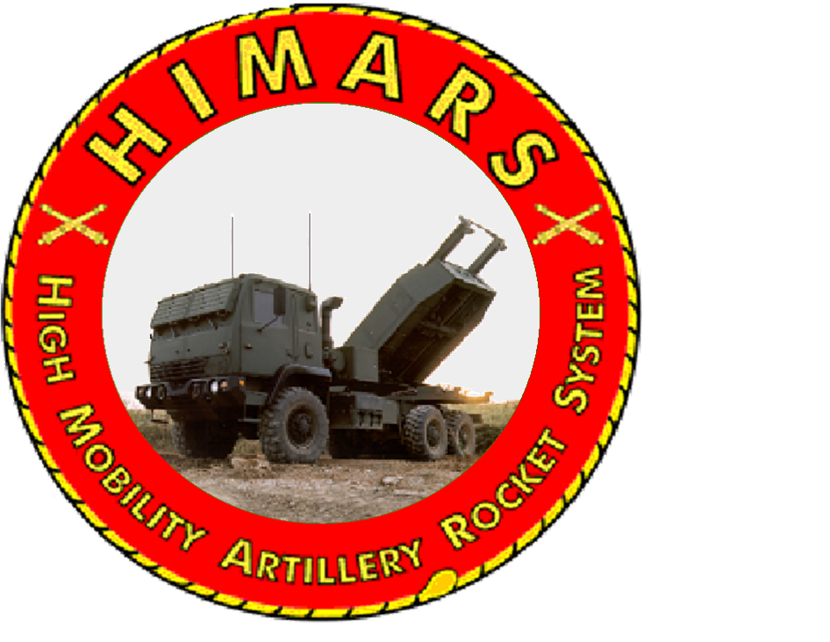



**Prepared 14 OCT 15**

**Security Classification: UNCLASSIFIED**

**INSTRUCTIONS TO STUDENTS:**

During this 120-minute period you will be tested on your knowledge of the HIMARS Ammunition Section Operations and Operator level maintenance. The examination consists of 40 multiple choice and TRUE/FALSE questions. All reference material and notes may be used.

1. Checking the fire extinguisher is an after operations check?
   1. TRUE 
   2. FALSE
2. What is the maximum speed for operating the CTIS in sand mode?
   1. 5 mph
   2. 40 mph
   3. 12 mph

### 55 mph

1. Checking the fuel water separator is a before operations check?

### TRUE

### FALSE

1. Loading MFOM RPs should be accomplished using the MHC remote control, ____ speed is recommended when maneuvering within two feet of lowering MFOM RPs into pod shoes on cargo bed.

### 10%

### 100%

### 30%

### 60%

### Operating in water or mud causes brake linings to get wet and can impair vehicle breaking, dry brakes by driving the vehicle _____ while applying service brakes often.

1. 200ft
2. 500ft
3. 250ft
4. 800ft

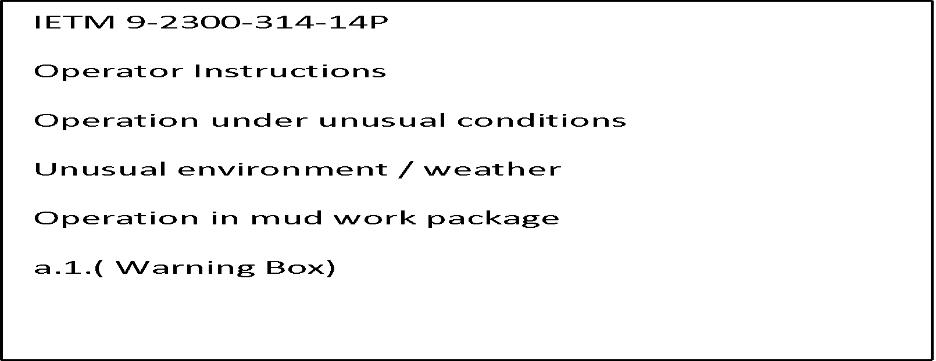

1. In normal driving mode the transfer case delivers what percent of torque to the front axle?

### 75%

### 80%

### 70%

### 30%

1. Before you disconnect the MHC remote controller you must first?

### Press the master stop button

### Select another function

1. Turn off the master power
2. Press the emergency stop switch on the remote
3. The RSV can ford water up to _____ inches of water. 

### 12

### 30

### 18

### 24

1. What is the DODAC for the Reduced Range Practice Round?

### H104

### H186

C. H185

D. HA22

1. After selecting mode on you TPSS, what range does the vehicle operate in?

### 4x6

### 2x6

### 4x4

### 6x6

1. You should not engage the engine exhaust brake when?

### Descending a slope in the desert

### When fording 40 in of water

### During icy or slippery conditions

### During air load operations

1. Reload points should be located at least ___meters from firing points and at least ___ meters from any other element.

### 200, 500

### 150, 200

### 800, 500

### 800, 1000

1. Loading and unloading MLRS MFOM RPs, the vehicle must be positioned on a level surface not to exceed ___ degrees in all axis combined.
2. 2
3. 3
4. 4
5. 5
6. Unless otherwise directed, _____ LPCs will be maintained at each LSP
7. Four
8. Two

###### One

1. Eight
2. The color code identification for an M39ATACMS is?
3. Blue
4. Pink with white dots

#### One large yellow square left front and right rear corner

1. One large brown square
2. What is the model number for the resupply trailer?
3. M1084A1

#### M1079

C. M1101

D. M1095

1. What is the turning radius for the RSV?
2. 100ft

#### 47 meters

C. 30 meters

D. None of the above

1. MFOM RPs weigh approximately ______ pounds?
2. 5000
3. 4700
4. 5500

#### 5100

1. The maximum boom extension of the MHC is?
2. 21 ft
3. 13 ft 4 in
4. 17 ft

#### None of the above

1. The Ammunition Holding Area should be located 100-300 meters from the platoon HQ?
2. True
3. False
4. How is the spare tire lowered?
5. Roll off method
6. Use of the MHC

#### The Hydraulic Manifold

1. The Inclinometer

22. The Coolant Temp indicator illuminates (red) when the engine coolant temperature is greater than ?

A. 180 C

B. 250 F

C. 200 C

D. 230 C

23. What is the tire pressure when in sand mode?

#### 22 psi

1. 55 psi
2. 35psi
3. 153kpa

24. A class III leak on the MHC deadlines it.

A. True

B. False



25. You dropped an MFOM 18 inches what do you do?

#### Have it inspected

1. Nothing
2. Inform the Launcher Chief at the ASP
3. Wipe it off drive on with the mission

26. The X-C (Cross-Country) Mode Button illuminates (red) when the tire pressure is ?

A. 25 psi.

B. 35 psi.

C. 37 psi.

D. None of the above.

27. The Inclinometer is graduated in what two types of measurements?

1. Centimeters and Millimeters

## Decameters and Feet

#### Degrees

1. Slope and Roll

28. What are the steps used to reset the CTIS?

1. Position master power switch to off, then position master switch to the on position.
2. Hold emergency and run flat simultaneously
3. Unplug the CTIS re plug it before the next engine start
4. Ignore it keep rolling

29. Before you connect the MHC remote to the power cable the remote button should be pushed in.

#### True

#### False

30. While using the MHC, all OLP led lights go red you should?

1. Hit the stop button

#### Reduce the pressure on the inner and outer booms

1. Hoist down on the cable
2. Press the OLP button on the remote

31. The MHC remote controller controls the outriggers and the cab tilt functions?

1. True
2. False

32. When charging the RST the park brake must be engaged?

1. True
2. False

33. The left and right side outriggers and jack cylinders may be operated from either side of the RSV?

1. True
2. False

34. The OLP switch on the MHC remote control provides ___ seconds of operation to allow movement to reduce pressure to the inner and outer boom.

1. 30
2. 15
3. 10
4. 20

35. The Inclinometer is used on vehicles to prevent ?

A. Flip-Over

B. Speeding

C. Traffic Tickets

D. UCMJ

36. What are the three speeds of the MHC remote controller?

1. 25, 50, 60
2. 60, 80, 100
3. 100, 60, 30
4. 100, 50, 20

37. What is the maximum load for the MHC when the load distance is 9’2”

1. 5500lbs
2. 7000lbs
3. 9600lbs
4. None of the above

38. Your wiper washer fluid is out where do you fill it?

1. Under the cab
2. In the drivers step plate
3. Behind the cab
4. Inside the fender

39. Recovering from air transport the CTIS is placed in which mode?

1. Highway mode
2. Cross country
3. Sand
4. Run flat and highway mode with hi idle on

40. In addition to secure radio communications, the RSV can be equipped with the ______.

A. Movement Tracking System

B. Command Post of the Future

C. Battlefield Operating System

D. Ammunition Placement Support Device

41. What is the weight of the M31A1?

A. 5069lbs

B. 5071lbs

C. 5111lbs

D. 4682lbs

42. Can burning rocket propellant be extinguished?

A. Yes

B. No

43. Do not smoke within ____ of a rocket pod or GMLA loading area.

A. 50 Feet

B. 50 Meters

C. 164 feet

D. Both B and C

44. Possible exposure to ignited rocket propellant requires immediate access to ____ for all operations outside of the cab.

A. Fire Extinguishers

B. Survivability Positions

C. NBC Masks

D. Decontamination Apparatus

45. Concerning the inspection of ammunition, what is a crack?

A. A narrow break in material

B. A slight depression

C. A slight scratch

D. A narrow shallow displacement of material from a surface

46. Which of the following conditions having occurred would be cause to reject a rocket pod or GMLA?

A. Crimped, frayed, loose, or broken wiring

B. Cracked, gouged, or shattered launch tubes

C. Cracks and/or bends on the lifting bar

D. All of the above

47. What is the drop criterion for the M28?

A. Less than 12 inches

B. More than 18 inches

C. More than 12 inches

D. No drop allowed

48. Operating temperature limits for MLRS RPs are ____.

A. -32̊ F to 160̊ F

B. -30̊ F to 160̊ F

C. -25̊ F to 140̊ F

D. -34.4̊ F to 71.1̊ C

49. All dropped rocket pods will be inspected.

A. True

B. False

50. Defects on the M28 are classified into one of four categories. Which of the following is not one of those categories?

A. Emergency

B. Major

C. Minor

D. Incidental

51. Which defect classification would a ground cable with 2 of the 7 strands completely severed meet?

A. Incidental

B. Minor

C. Emergency

D. Major

52. Flammable liquids must be stored at least ____ from the nearest ammunition item being processed.

A. 50 meters

B. 50 feet

C. 100 meters

D. 100 feet

53. What are the storage temperature limits for GMLRS?

A. -30̊ F to 160̊ F

B. -34̊ F to 171̊ F

C. -25̊ F to 140̊ F

D. -32̊ C to 200̊ F

54. What is the correct definition of the acronym QASAS?

A. Quality Assurance Specialist for Ammunition Surveillance

B. [Quality Assurance Reporting Requirements](http://www.acronymfinder.com/Quality-Assurance-Reporting-Requirements-(QARR).html)

C. Quality and Safety Achievement Recognition

D. Quality Assurance Systems Analysis Review

55. Before transporting ammunition, which form shall be used to inspect motor vehicles?

A. SF 3

B. DA Form 214

C. DD Form 626

D. DA Form 581

56. DODIC stands for Department of Defense Identification Code?

A. True

B. False

57. The difference between operational load ammunition and training load ammunition, is what you use them for, e.g. funeral detail, or M4 Qualification Range.

A. True

B. False

58. A DA FORM 5515 is used to sign Class V Ammunition to a different person, whom did not sign for the ammunition, from the ASP.

A. True

B. False

59. The tarpaulin needed for covering ammunition on a truck must be fire-retardant.

A. True

B. False

60. What must be accomplished in order to turn in live ammunition and residue?

A. Segregated by type

B. Mix ammunition

C. Annotated on DA Form 5502, that all ammunition has been repackaged

D. Bury the ammunition that failed to function correctly

61. Which types of ammunition may be stored in the unit arms room?

A. All ammunition types

B. depends on the arms room certification

C. No ammunition can be stored in the arms room, at any time

D. None of the Above

62. Who shall prepare a Field ASP request, and who needs to sign/approve of it.

A. The battery commander

B. Personnel picking up ammunition

C. The S-3, Ammunition Manager, Range Control, and QASAS

D. No request for a FASP is necessary.

63. What must you do to ammunition when using it at a range?

A. Ensure that only ammunition needed at the moment is opened.

B. Break all seals to all cans

C. Load all weapons systems, and make sure all ammo is taken out of the cans

D. Use the round as a hammer

64. When turning in live and residue, two copies of DA 581's are necessary. One for live, and one for residue.

A. True

B. False

65. A SFC, must inspect all ammunition before it can be turned in, what is the purpose of this?

A. To look at the ammo, and see how shiny it is

B. To verify that lot numbers on the ammunition match the lot number on the ammo can

C. Break seals on all ammo cans that are unopened

D. Verify count of rounds shot at the range

66. How long do you have to turn in all ammunition, after the training exercise?

A. However long it takes to get it done

B. 24 hours

C. 5 business days

D. 30 days

67. Explain the purpose of the amnesty program?

A. To make a turn in easier, it does not require a DA Form 581

B. To turn in found ammunition, after reconciling and closing out a document number

C. To turn in duds, misfired rounds

D. It is only a trashcan, you cannot put ammunition in it

66. Where can information on specific weapons qualifications (STRAC) be found?

A. DA PAM 350-39

B. DA Form 581

C. AR 670-1

D. DA Form 626

67. Which of the following is considered category II ordnance?

A. Hand Grenades, and mines

B. .50 Cal or below

C. Only EOD uses these

D. Anything that blows up

68. Category I ammunition, such as an AT-4 is considered to be in a 'ready-to-fire' configuration, meaning the round is inside the tube it is fired from, and does not require anything else in the package, to fire the round.

A. True

B. False

69. What is the proper action to be taken upon discovery of a suspected dud?

A. Bury it

B. Conspicuously mark and report duds to range control

C. Burn it

D. Ignore it

70. When storing Category I ammunition in a Field ASP, it must be under constant armed guard.

A. False

B. True

71. Once a Field ASP is established, and everything is inventoried, the following shall happen?

A. Establish four entry control points

B. Inventory all my ammunition, and every 24 hours

C. At least 30% guard must be established

D. All of the above

72. When drawing ammunition, the following must be in the vehicle

A. 2, 10BC Fire Extinguishers

B. 4, 5 BC Fire Extinguishers

C. 1, 45CD HALON Fire Extinguisher

D. The Fire extinguisher assigned to the vehicle is sufficient

73. What is AFOP?

A. Ammunition Found on Post

B. Ammunition Frequency Officer Position

C. Agency for Official Permissions

D. A component of MFOM

74. Block 28 on the DA Form 581 requires this statement: *"Contents have been inspected. They do not contain any live rounds, unfired primers, explosives, or other dangerous material and do not constitute hazardous waste munitions as defined in the EPA-MR."*

Who signs in this block, certifying the above statement?

A. Ammunition handler

B. The battalion commander

C. SFC or above

D. whoever is there to sign it

Chapter 6-3 paragraph D (page 70)

75. Which chapter in the ASP External SOP covers Operational Loads?

A. Chapter 3

B. Chapter 4

C. Chapter 2

D. Appendix G